Challenge Yourself!
****KS1****
WEEK 6
Can you…...
- Can create 10 different ways to balance around the house? Can you take photos of them?
- Have a look at the Sporting Start Workout Videos on YouTube.. Your Parents can use the link below: https://www.youtube.com/channel/UCgKjH7HO7MGly1DW56614Aw
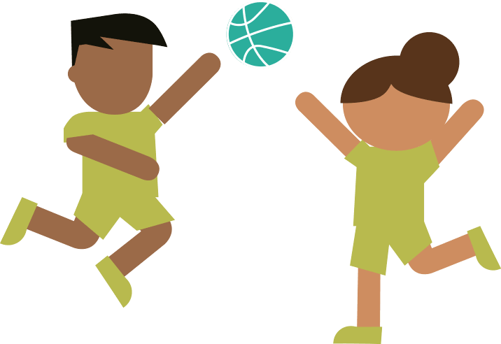
- Go on a nature walk can you identify:
  - 5 different trees
  - Blossom
  - 5 different flowers
  - 5 different birds
- Can you go on a bike ride with someone in your family?
- Have a go at the following:
- Hopping
- Skipping
- Jumping
- Leaping
- Create your own hopscotch in the garden
- Can you bounce a ball like a basketball? Can you dribble the ball? Can you do a figure of 8 around your legs with the ball?

